

SwanVLM User Guide [v7.0]



Swansea University

College of Engineering

Zienkiewicz Centre for Computational Engineering

Contents

What is SwanVLM? 2

How does it work? 2

What can SwanVLM do? 2

How to use SwanVLM 3

Inputting Geometry Data 3

Example Geometry Data 5

Inputting Environment Data 9

Inputting Meshing Data 10

Additional Files 10

DELTA 10

ELLIPSE 12

Running SwanVLM 13

# What is SwanVLM?

SwanVLM is a MATLAB based vortex lattice method code. Its primary use case is for doing preliminary aerodynamic analysis on aircraft configurations early in on the design cycle.

The code features the ability to dimension a variety of different aircraft wing geometries, from conventional wing shapes to more obscure shapes such as a delta or elliptical wing.

# How does it work?

Please refer to the dissertation written by the original composer of SwanVLM, Christopher Walton, titled ‘The 3D Aerodynamics of Lifting Surfaces Using Vortex Lattice Methods’, for a more in-depth explanation of the fundamentals of the code. Please note that the code has seen many iterations since it was originally developed, and hence the dissertation may not contain explanations for all the current features of the code.

# What can SwanVLM do?

SwanVLM is comprised of four main working functions, which allow for varying aircraft wing configurations to be tested. Regardless of which of the functions are chosen to be executed, the same results are output from the program. These are the: effective angle of attack, coefficient of lift, and coefficient of drag found at each angle of attack defined in the input file. Other values that are included in the output are the coefficient of lift at zero angle of attack, rate of change of coefficient of lift per degree, aerodynamic centre, coefficient of moment per degree, static margin, reference chord length in meters, and the reference area in m2.

Four unique figures are also generated to visually represent the calculated data. These figures in order of generation are the: ‘Mesh for geometry’ figure, ‘CL and CD vs Alphageo­’ figures, ‘Pressure distribution for geometry’ figure, and ‘Spanwise lift distribution’ figure.

Function ‘1’ (Single Horizontal Lifting Surface) allows testing of one horizontal aerofoil geometry. This feature is expected to be used for preliminary testing of the main wing of an aircraft at the very initial stages of aircraft aerodynamic development.

Function ‘2’ (Multiple Horizontal Lifting Surfaces) allows for testing of two horizontal aerofoil geometry. This feature is expected to be used for testing after the user has decided on the general geometry of the main wing and is aiming to focus on the geometry of the rear horizontal stabiliser.

Function ‘3’ (Vertical Aerodynamic Surfaces Only) allows for testing of one vertical aerofoil geometry. This feature is expected to be used for testing of the rear vertical stabiliser for directional stability.

Function ‘4’ (Full aircraft configuration) allows for the testing of all the features found in functions ‘2’ and ‘3’ together, so it would be expected to be the geometry of all components (main wing, horizontal stabiliser, and vertical stabiliser) of the aircraft.

# How to use SwanVLM

The input geometry must be fed into SwanVLM in a very particular format, in accordance with the template input .xls file provided.

The main geometry of the wing/s will be defined in the first page of the file. On the second page, environmental variables can be altered. On the third page, variables related to the meshing of the geometry can be altered. Once SwanVLM has calculated the results, they will be stored on the pages following.

## Inputting Geometry Data

The following section will cover how to input geometry data into the input file.

Here several input parameters will be found, as shown below split into two figures for better visibility.



In the **Wing** column, the number of the current wing that the data is describing must be entered, starting from ‘1’ and ascending to the final ‘nth’ wing. For functions ‘1’ and ‘3’, only one wing is supported, hence the wing number cannot exceed ‘1’. This value must be entered for each row in which there is geometry data.

In the **Section** column, the number of the current section of the wing that the data is describing must be entered, starting from ‘1’ and ascending to the final nth’ section. The ‘Section’ number is independent to the wing, and hence must be labelled starting from ‘1’ for each new wing that is defined.

In the **Ref Point** columns, the ‘x’, ‘y’, and ‘z’ coordinates of the leading tip of the wing must be entered. This defines where the wing is located in 3D space (in meters) and allows SwanVLM to accurately place the wings in space, where multiple wings are present. These values must be entered for each new wing geometry, but only for the first section as labelled. If the testing is only being conducted on one wing geometry, the default values of ‘0’, ‘0’, ‘0’ may be used.

In the **Root Profile** column, the aerofoil shape at the root of the first section must be defined. This must be either a .dat file that is already found in the ‘Airfoils’ folder or must be a new file that must be created and stored in the ‘Airfoils’ folder using the ‘selig’ dat format. Furthermore, if a NACA 4-digit aerofoil shape is desired, the four-digit code can simply be entered into this field, preceded by a ‘n’. For example, to input the NACA0012 aerofoil, the text ‘n0012’ can be input, and the code will recognise this and automatically generate the required aerofoil shape. This input must be entered for each new wing geometry, but only for the first section as labelled.

In the **Root Chord** column, the aerofoil root chord length (in meters) of the first section must be defined. This value must be entered for each new wing geometry, but only for the first section as labelled.



In the **Tip Profile** column, the aerofoil shape at the tip of the current section must be defined. The input format for this column is very similar to that of the ‘root profile’ column, and the previously mentioned input formatting also applies here. It must be noted that the profile that is defined as the ‘tip profile’ of the current section will be the ‘root profile’ of the following section.

In the **Tip Chord** column, the aerofoil tip chord length (in meters) of the first section must be defined. Much like the data carryover present in the ‘tip profile’ column, the ‘tip chord’ of the current section will be the ‘root chord’ of the following section.

In the **Section Span** column, the span of the current section (in meters) must be defined.

In the **Section Sweep** column, the sweep angle of the current section (in degrees) must be defined about the leading edge.

In the **Section Dihedral** column, the dihedral angle of the current section (in degrees) must be defined.

In the **Root Inc** column, the inclination of the wing at the root of the current section (in degrees) must be defined.

In the **Tip Inc** column, the inclination of the wing at the tip of the current section (in degrees) must be defined.

In the **Mirrored in zx-plane** column, whether the user desires the wing geometry to be mirrored about the zx-plane must be defined with a ‘1’ or a ‘0’. An input of ‘1’ will mirror the geometry, and an input of ‘0’ will leave the geometry unmirrored.

In the current version of SwanVLM, the ‘Inverted’ column does not serve a purpose, however in future updates will act as a flag to switch the root and tip aerofoil profiles for the current section, using an input of a ‘1’ or a ‘0’, where ‘1’ will invert the aerofoil shapes, and ‘0’ will leave the aerofoils noninverted.

### Example Geometry Data

The following are examples of input geometry for each of the four functions that SwanVLM possess, to help the user better understand the format that the input file is expected to be in. These files will be included in the SwanVLM package.

**File name: ‘**piper28aMW.xls’

**SwanVLM function:** ‘1’

**Input file:**





**Aircraft geometry:**

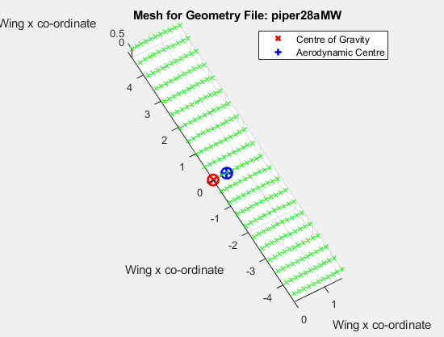

**File name: ‘**piper28aHWs.xls’

**SwanVLM function:** ‘2’

**Input file:**

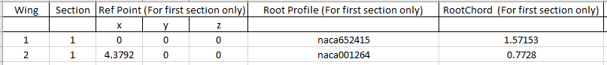



**Aircraft geometry:**

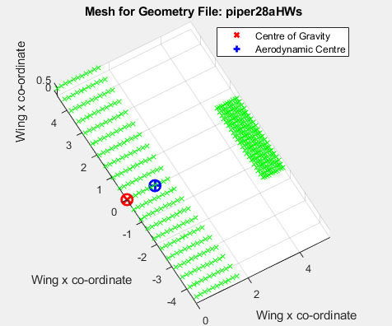

**File name: ‘**piper28aVT.xls’

**SwanVLM function:** ‘3’

**Input file:**





**Aircraft geometry:**

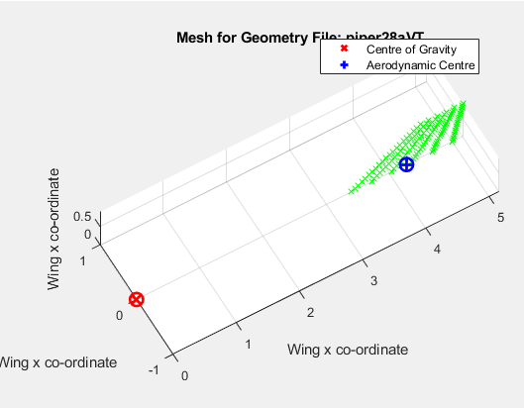

**File name: ‘**piper28aHWs.xls’ + ‘piper28aVT.xls’

**SwanVLM function:** ‘4’

**Input file:**

Horizontal geometry:





Vertical geometry:





**Aircraft geometry:**

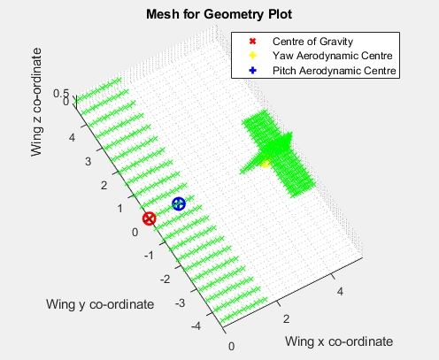

## Inputting Environment Data

The following section will cover how to input environment data into the input file.

The main environmental inputs into SwanVLM include the density of air (rho), the freestream velocity (V), and the centre of gravity of the test platform. Also included are the min and max angle of attack to be tested, the angle of attack increment, and the sideslip angle (beta).

The value of **rho** can be set to match the density of air at the altitude at which the simulation is preferred to be ran at, measured in Kg/m3. By default, this value is set to 1.225 – the density of air at sea level.

The value of **V** can be altered to define the velocity of the freestream air in the simulation, measured in m/s. By default, this value is set to 30.

The **CofG** can be defined using ‘x’, ‘y’, ‘z’ coordinates (measured in meters) to show weight distribution of the aircraft. The default coordinates are set to ‘0’, ‘0’, ‘0’, which are incident with the default reference point of the tip of the main wing.

For analysis at varying angels of attack, the **Alpha Min**, **Alpha Max**, and **Alpha Increment** values can be manipulated to test the input geometry under a multitude of flying conditions. The ‘Alpha Min’ variables defines the starting angle of attack for testing, ‘Alpha Max’ defines the final angle of attack for testing, and ‘Alpha Increment’ defines the increase in angle of attack, per step, from the ‘Alpha Min’ to ‘Alpha Max’. By default, these values are set to 0, 5, and 1 respectively.

The value of **Beta** defines the sideslip angle of the aircraft, measured in degrees. By default, this value is set to 0.

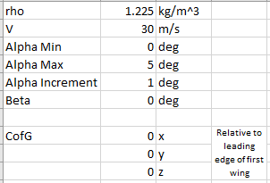

## Inputting Meshing Data

The following section will cover how to input meshing data into the input file.

The meshing in SwanVLM is achieved through dividing the sections of the wings into smaller panels. The number of panels that are present in each section can be defied in the ‘Meshing’ page of the input file.

The **Section Chordwise Panels** variable defines the number of panels that will be created along the root chord of each section.

The **Model Total Panels** variables defines the target total number of panels per each section.

Increasing either of these values by a large number will significantly increase the computation time of the program, as that would greatly increase the mesh density.



## Additional Files

You will find an included .xls file which will help with the calculations to plot specific wing shapes.

Currently the support wing shapes include:

* Delta
* Ellipse

This file removes the calculation steps to input the geometry into SwanVLM for a smoother user experience. Found within the file are two tabs, ‘REF’, ‘DELTA’, and ‘ELLIPSE’. The ‘REF’ tab is purely to assist calculations that take place in other tabs and can be ignored.

### DELTA

The ‘DELTA’ tab includes two separate input fields for the user to choose whether they would like to define the wing using a chord length-span length combination, or a chord length-sweep angle combination.

To use the tab, simple input the desired values into the ‘INPUT’ tables and copy the output values into the relevant fields in the SwanVLM data input file. For reference, in the default SwanVLM input file, the span input field is found at the G3 cell, and the sweep angle input field is found at the K3 cell. For the current version, there is no build-in feature for the program to detect that the input geometry is a delta wing, however this will be included in the next update. For the time being, a very small tip chord value (0.00001) may be used to emulate this effect.

Show below are the inputs as they will be found in the excel file, and a reference aircraft, displaying the expected input geometry.

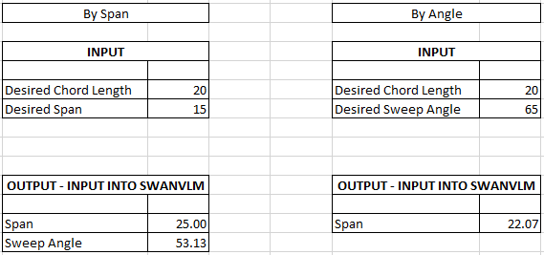

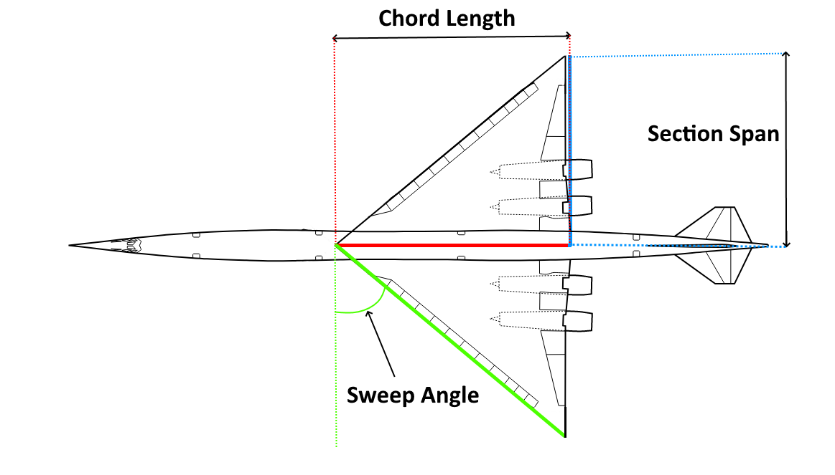

### ELLIPSE

The ‘ELLIPSE’ tab includes two inputs, Chord and Span. Refer to the included diagram of the reference aircraft to understand the expected input geometry. The equations built into the spreadsheet will use the input values to properly scale the ellipse wing shape and convert the values to be compatible with the required input fields of SwanVLM.

To input the geometry into SwanVLM, select the cells between A1 and P17, and copy these cells. Next, navigate to a new SwanVLM input template file. Right-click on the A3 cell and select ‘Values’, under the ‘Paste Options’ field. An image of this icon from the right click menu is shown below. This is a critical step, as just pasting the cells in a regular fashion will not copy the values correctly, and lead to an error.



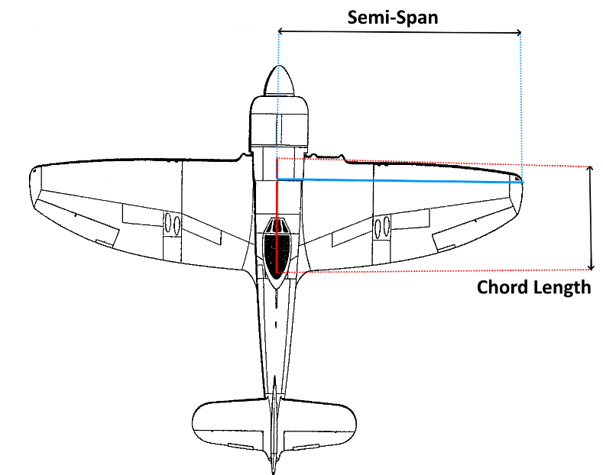

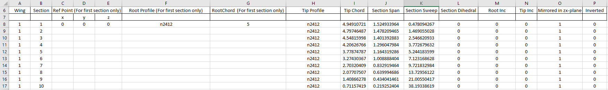

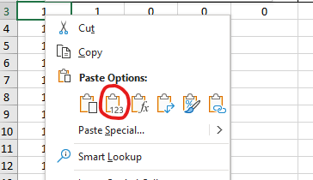

## Running SwanVLM

Prior to launching SwanVLM, ensure that any input files that are intended to be used are closed, as the program will crash due to not being able to write the results to the files if they are open. To launch SwanVLM, navigate to the …\SwanVLM_BetaVersion-master directory, and type ‘SwanVLM’ in the Command Window (excluding the apostrophe).

The four functions will be presented as options:

1. Single Horizontal Lifting Surface
2. Multiple Horizontal Lifting Surfaces
3. Vertical Aerodynamic Surfaces Only
4. Full aircraft configuration

Type the number related the option relevant to the test case, from the recommended use cases in the ‘What can SwanVLM do?’ (Pg. 2) section and press the ‘Enter’ key to send the command.

For options ‘1’, ‘2’, and ‘3’, the program will request the name of the input file to be submitted. Type the name of the input file exactly as it appears and press the ‘Enter’ key. The program will perform the analysis on the geometry as defined on the input file and will write the results to the input file in a new page. After this, the program will ask if the user permission to display figures related to simulation. Typing ‘y’ and pressing the ‘Enter’ key will generate the figures previously outlined (Pg. 2). Typing ‘n’ and pressing the ‘Enter’ key will close and exit the program.

If option ‘4’ is selected, first the program will request the name of the input file for the horizontal geometry. Once this has been submitted as per instructed in the previous paragraph, the program will perform the analysis and write the results to the horizontal geometry input file. Next, the program will ask if the user permission to display figures relevant to simulation. As explained previously, this can be accepted or dismissed. Accepting this prompt will display the figures from the simulation for the horizontal surfaces only. Next the program will request the name of the input file for the vertical geometry. Once this has been submitted, the program will perform the analysis again, on the vertical geometry, and write the results to the vertical geometry input file. Again, the program will request permission to display the figures relevant to the simulation. Accepting this prompt will display the figures from the simulation for the vertical surfaces only. Finally, the program will request the user permission to display the full geometry plot. Accepting this prompt will display the figures from the simulation for the horizontal surfaces only. Upon completion, the program will close, and another input geometry may be submitted for analysis again.